SANDWICH /WOODNESBOROUGH
Parish Council Monthly update
DECEMBER
PCSO –Debbie BISHOP

Welcome to this months update. Below you will find details of recent activity in your area and campaigns that are currently being run by Kent Police alongside our partner agencies.
Contacting Kent Police
Please remember in an emergency, always dial 999
For any non-emergency enquiries, please use The Kent Police website where we have the following facilities:-
Speak to one of our team online who will be able to assist you.
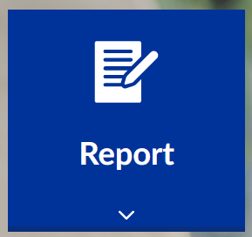 Report a crime, anti-social behaviour, Road Traffic incident etc.
Events or updates to a case or report.
For more information, visit our website – www.kent.police.uk
Or follow us on Twitter @kentpolicedover
My Community Voice is a 2-way messaging service that helps Kent residents, businesses & community groups to keep in touch with their local Policing teams.
Sign up to My Community Voice at www.mycommunityvoicekent.co.uk
Good evening to you all,
As we now are coming to the end of the year and looking forward to Christmas and the new year , can we all keep an eye on your vulnerable neighbours and if you think they are in need of a chat or a visit to see if they need help then please don’t hesitate to call us and this can be arranged, we can help with letting them know regarding the warm spaces available and also deliver some food packs for anyone struggling, this week ive delivered three to local people and the Pantry in Sandwich has seen more people taking up the offer of help this is open to all who needs this service so just pop along and sign up in ST Peters Church.
Please also be aware of local scammers that are praying on the vulnerable at the moment, if in doubt don’t answer the phone, door,or reply to any texs messages, or emails get them checked first as they may seem genuine and they are very well worded and written. The above shows how you can contact Kent Police. Kind Regards Merry Christmas Pcso Debbie Bishop
me

