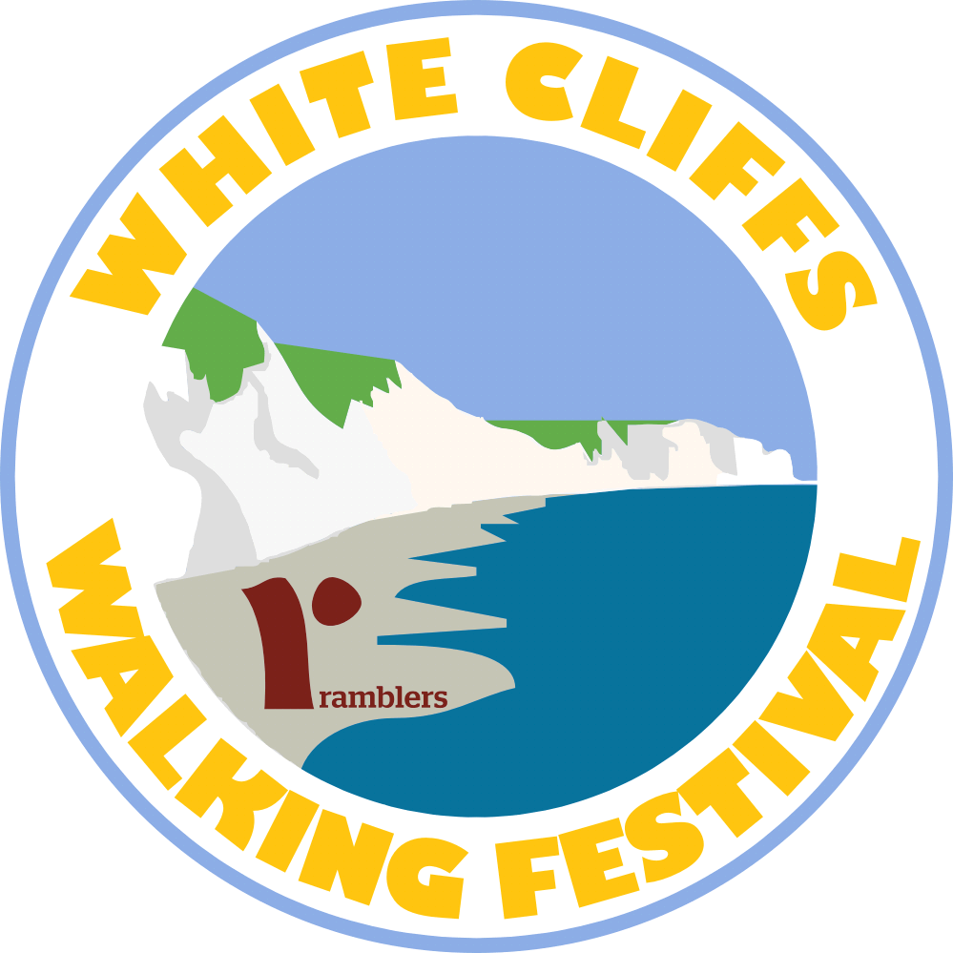 | FESTIVAL INFORMATION RELEASE  White Cliffs Walking Festival  Thursday 26th to Tuesday 31st August 2021
A Covid aware festival.
Over the August Bank Holiday Weekend.
“Not just a walk - an EXPERIENCE!”

Historical Walks, Country Walks, Coastal Walks and Carers Walk, plus the 30 mile White Cliffs Challenge with the Long-Distance Walkers Association
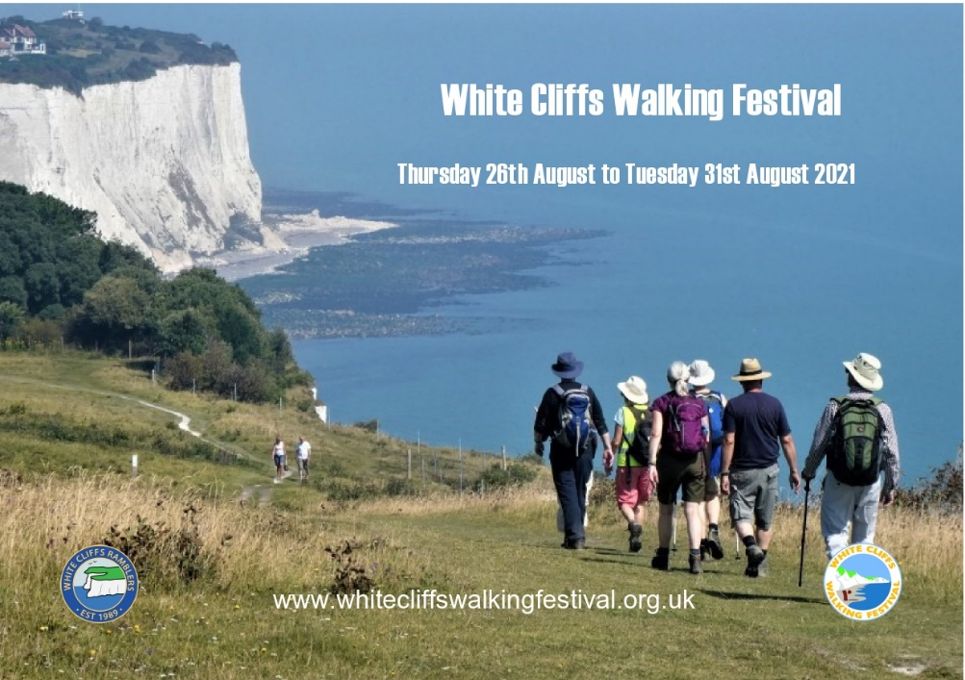

Visit us or contact the festival through our website www.whitecliffswalkingfestival.org.uk
Booking in advance is essential, a maximum of 20 on each walk
The festival, organised by the local White Cliffs Ramblers group, is now in its 7th year. An ever popular festival attracting both locals and visitors, some returning year after year. In 2019 we attracted 1250 delighted walkers, this year we have restrictions in place. Walks must be booked in advance bookings will be taken from the 1st July.
Centred on the historic towns of Dover, Deal, Sandwich and Folkestone, this festival features 33 walks ranging in length from 2 to 30 miles. Whatever your walking ability or interest, we offer walks that will tempt you to discover our beautiful coast and nearby countryside. Immerse yourself walking among Dover’s fascinating military fortifications or take in the delightful coastal views. Most walks are free, though a voluntary contribution would be appreciated please. A few of our special guided walks cost a very modest amount to cover the costs of specialist speakers.
@whitecliffsfest whitecliffswalkingfestival
The White Cliffs Walking Festival created and organised by the White Cliffs Ramblers www.whitecliffsramblers.org.uk
Charity No 1093577

